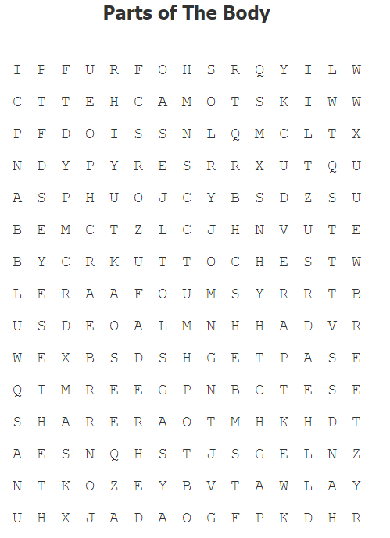

|  |  |  |  |
| --- | --- | --- | --- |
| Brazos | Manos | Rodillas | Oreja |
| Ojos | Pecho | Cuello | Cabeza |
| Piernas | Nariz | Estómago | Boca |
| Hombros |  |  |  |

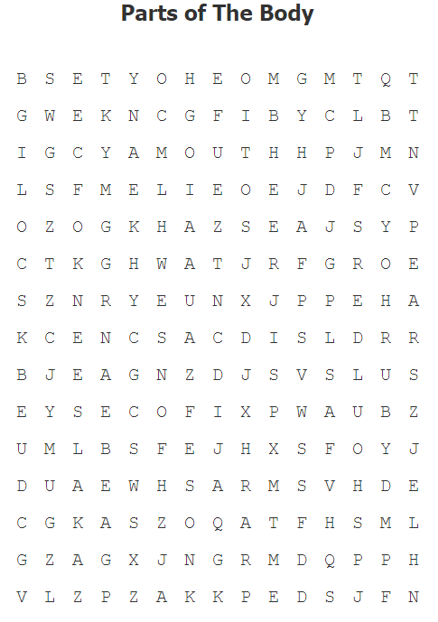

|  |  |  |  |
| --- | --- | --- | --- |
| Brazos | Manos | Rodillas | Oreja |
| Ojos | Pecho | Cuello | Cabeza |
| Piernas | Nariz | Estómago | Boca |
| Hombros |  |  |  |

